NAME:___________________________________________________Phone no.____________________________

Closed, Monday, January 1st for New Year’s Day and No Lessons on Monday, February 9th for President’s Day. 11/20-11/24

11/20-11/24

**Project R.I.D.E., Inc.**

**January 2 to March 8, 2024**

**Please mark all of your availability. We will confirm your schedule with you.**

The first and last shift of every day includes lesson prep and barn chores.

|  |  |  |
| --- | --- | --- |
| Monday | * 7:30am- 10:30am * 10:30am- 1:30pm * 1:30pm- 4:45pm * 4:45pm- 7:30pm | **1/8,** 1/15, 1/22, 1/29, 2/5, **2/12**, 2/26, **3/4**  NO LESSONS: 1/1 and 2/19  **Orientations: 1/8, 2/12, and 3/4** |
| Tuesday | * 7:30am- 10:30am * 10:25am-1:30pm * 1:30pm- 4:45pm * 4:45pm- 8:15pm | 1/2, 1/9, 1/16, 1/23, 1/30, 2/6, 2/13, 2/20, 2/27, 3/5, |
| Wednesday | * 7:30am- 10:30am * 10:25am-1:30pm * 1:30pm- 4:45pm * 4:45pm- 8:15pm | 1/3, 1/10, 1/17, 1/24, 1/31, 2/7, 2/14, 2/21, 2/28, 3/6 |
| Thursday | * 7:30am- 10:30am * 10:25am-1:30pm * 1:30pm- 4:45pm * 4:45pm- 8:15pm | 1/4, 1/11, 1/18, 1/25, 2/1, 2/8, 2/15, 2/22, 2/29, 3/7 |
| Friday | * 7:30am- 10:30am * 10:25am-1:30pm * 1:30pm- 4:45pm | 1/5, 1/12, 1/19, 1/26, 2/2, **2/9**, 2/16, 2/23, 3/8 |

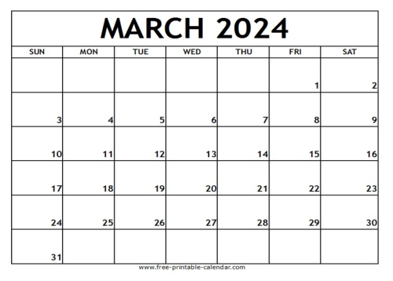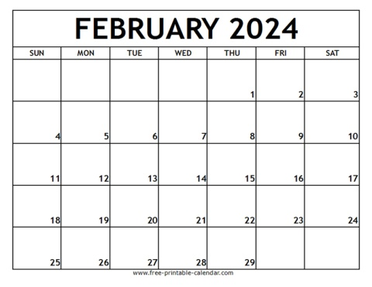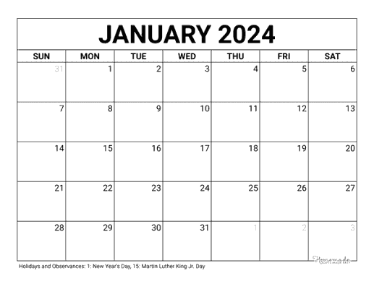

Volunteers Always Needed!

***Thank you for making the magic happen!***

**If you must cancel your shift, please call 916-685-7433**