NAME:___________________________________________________Phone no.____________________________
Project R.I.D.E., Inc.
March 18th to May 24th 2024
Please mark all of your availability. We will confirm your schedule with you.
The first and last shift of every day includes lesson prep and barn chores.

Monday | - 7:30am- 10:30am  - 10:30am- 1:30pm  - 1:30pm- 4:45pm  - 4:45pm- 7:30pm | 3/18, 3/25, 4/1, 4/8, 4/15, 4/22, 4/29, 5/6, 5/13, 5/20  NO LESSONS: 3/11  Orientations: 3/4, 4/1, and 5/6
Tuesday | - 7:30am- 10:30am  - 10:25am-1:30pm  - 1:30pm- 4:45pm  - 4:45pm- 8:15pm | 3/19, 3/26, 4/2, 4/9, 4/16, 4/23, 4/30,5/7, 5/14, 5/21  NO LESSONS: 3/12
Wednesday | - 7:30am- 10:30am  - 10:25am-1:30pm  - 1:30pm- 4:45pm  - 4:45pm- 8:15pm | 3/20, 3/27, 4/3, 4/10, 4/17, 4/24, 5/1, 5/8, 5/15, 5/22  NO LESSONS: 3/13
Thursday | - 7:30am- 10:30am  - 10:25am-1:30pm  - 1:30pm- 4:45pm  - 4:45pm- 8:15pm | 3/21, 3/28, 4/4, 4/11, 4/18, 4/25, 5/2, 5/9, 5/16, 5/23  NO LESSONS: 3/14
Friday | - 7:30am- 10:30am  - 10:25am-1:30pm  - 1:30pm- 4:45pm | 3/22, 3/29, 4/5, 4/12, 4/19, 4/26, 5/3, 5/10, 5/17, 5/24  NO LESSONS: 3/15
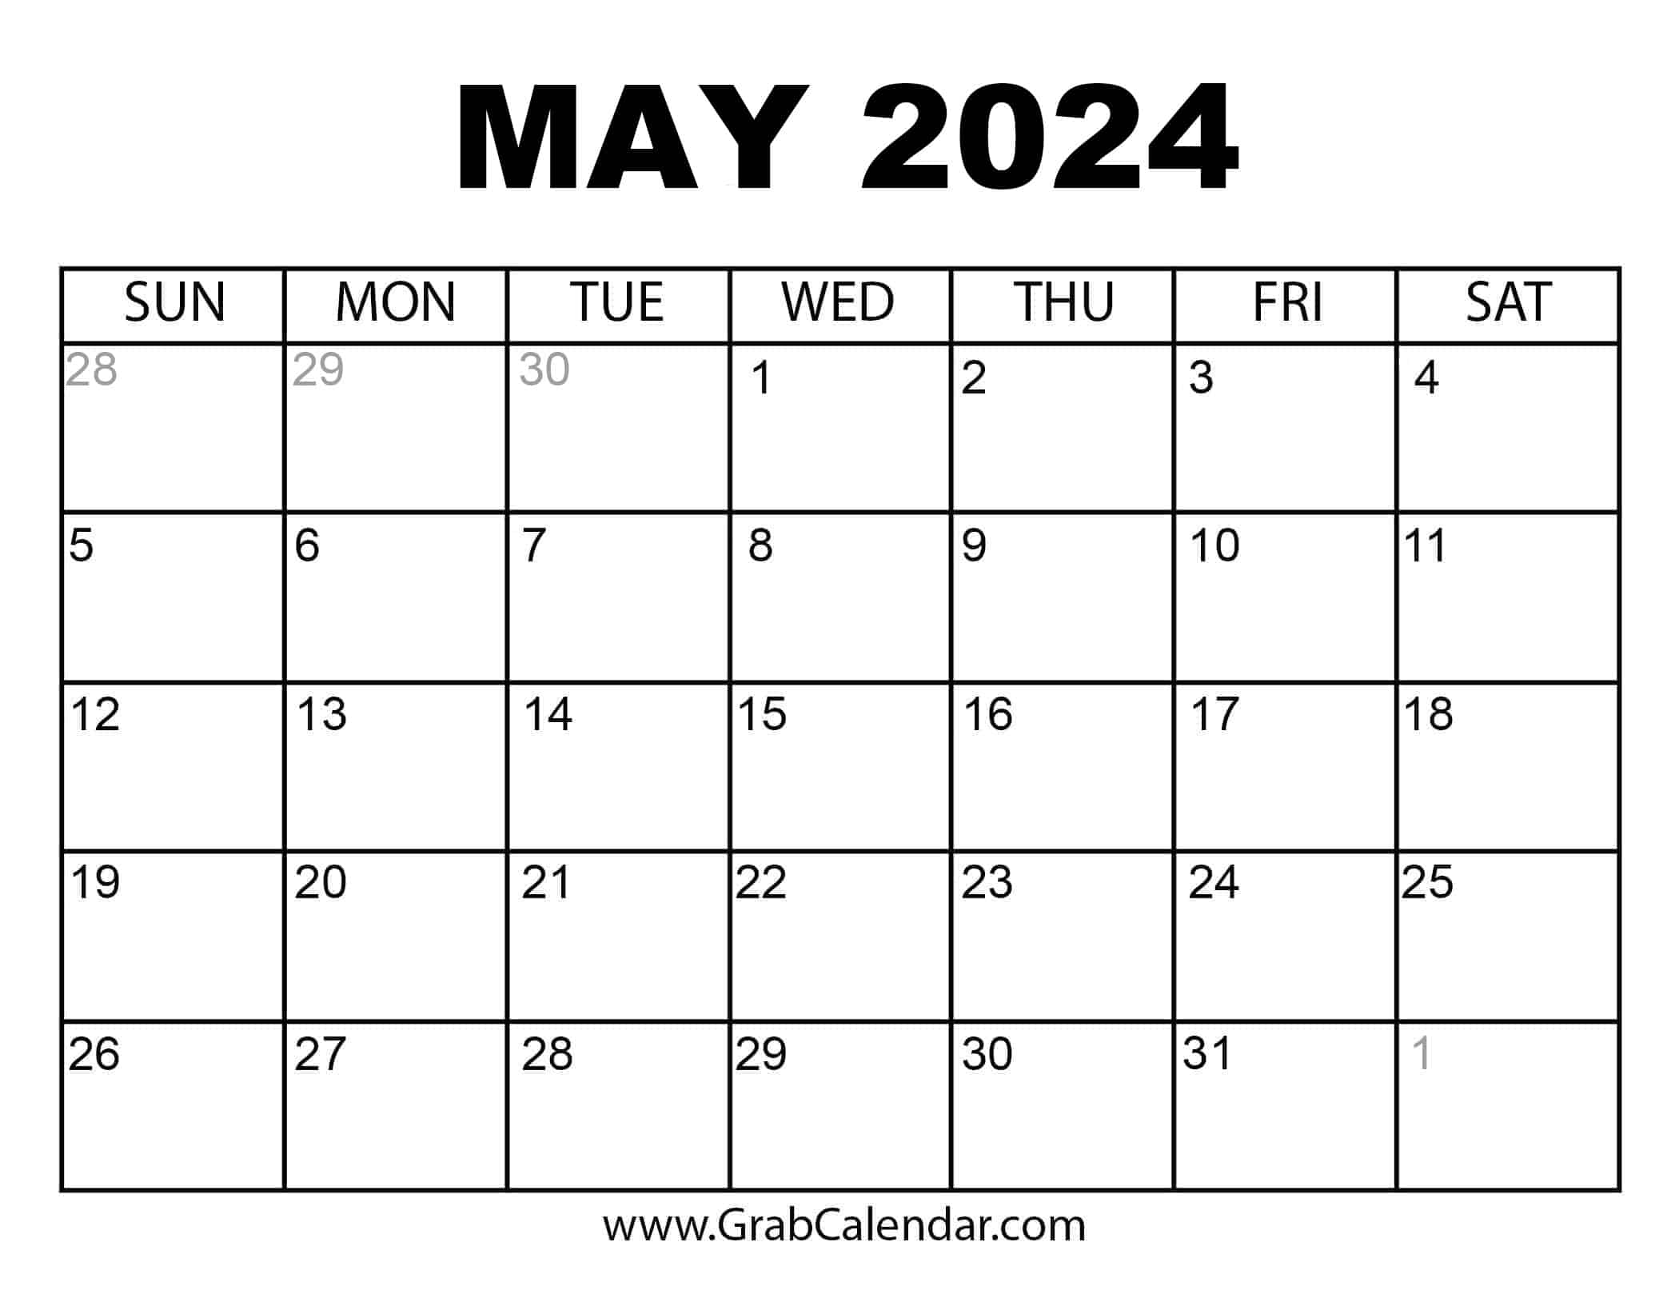
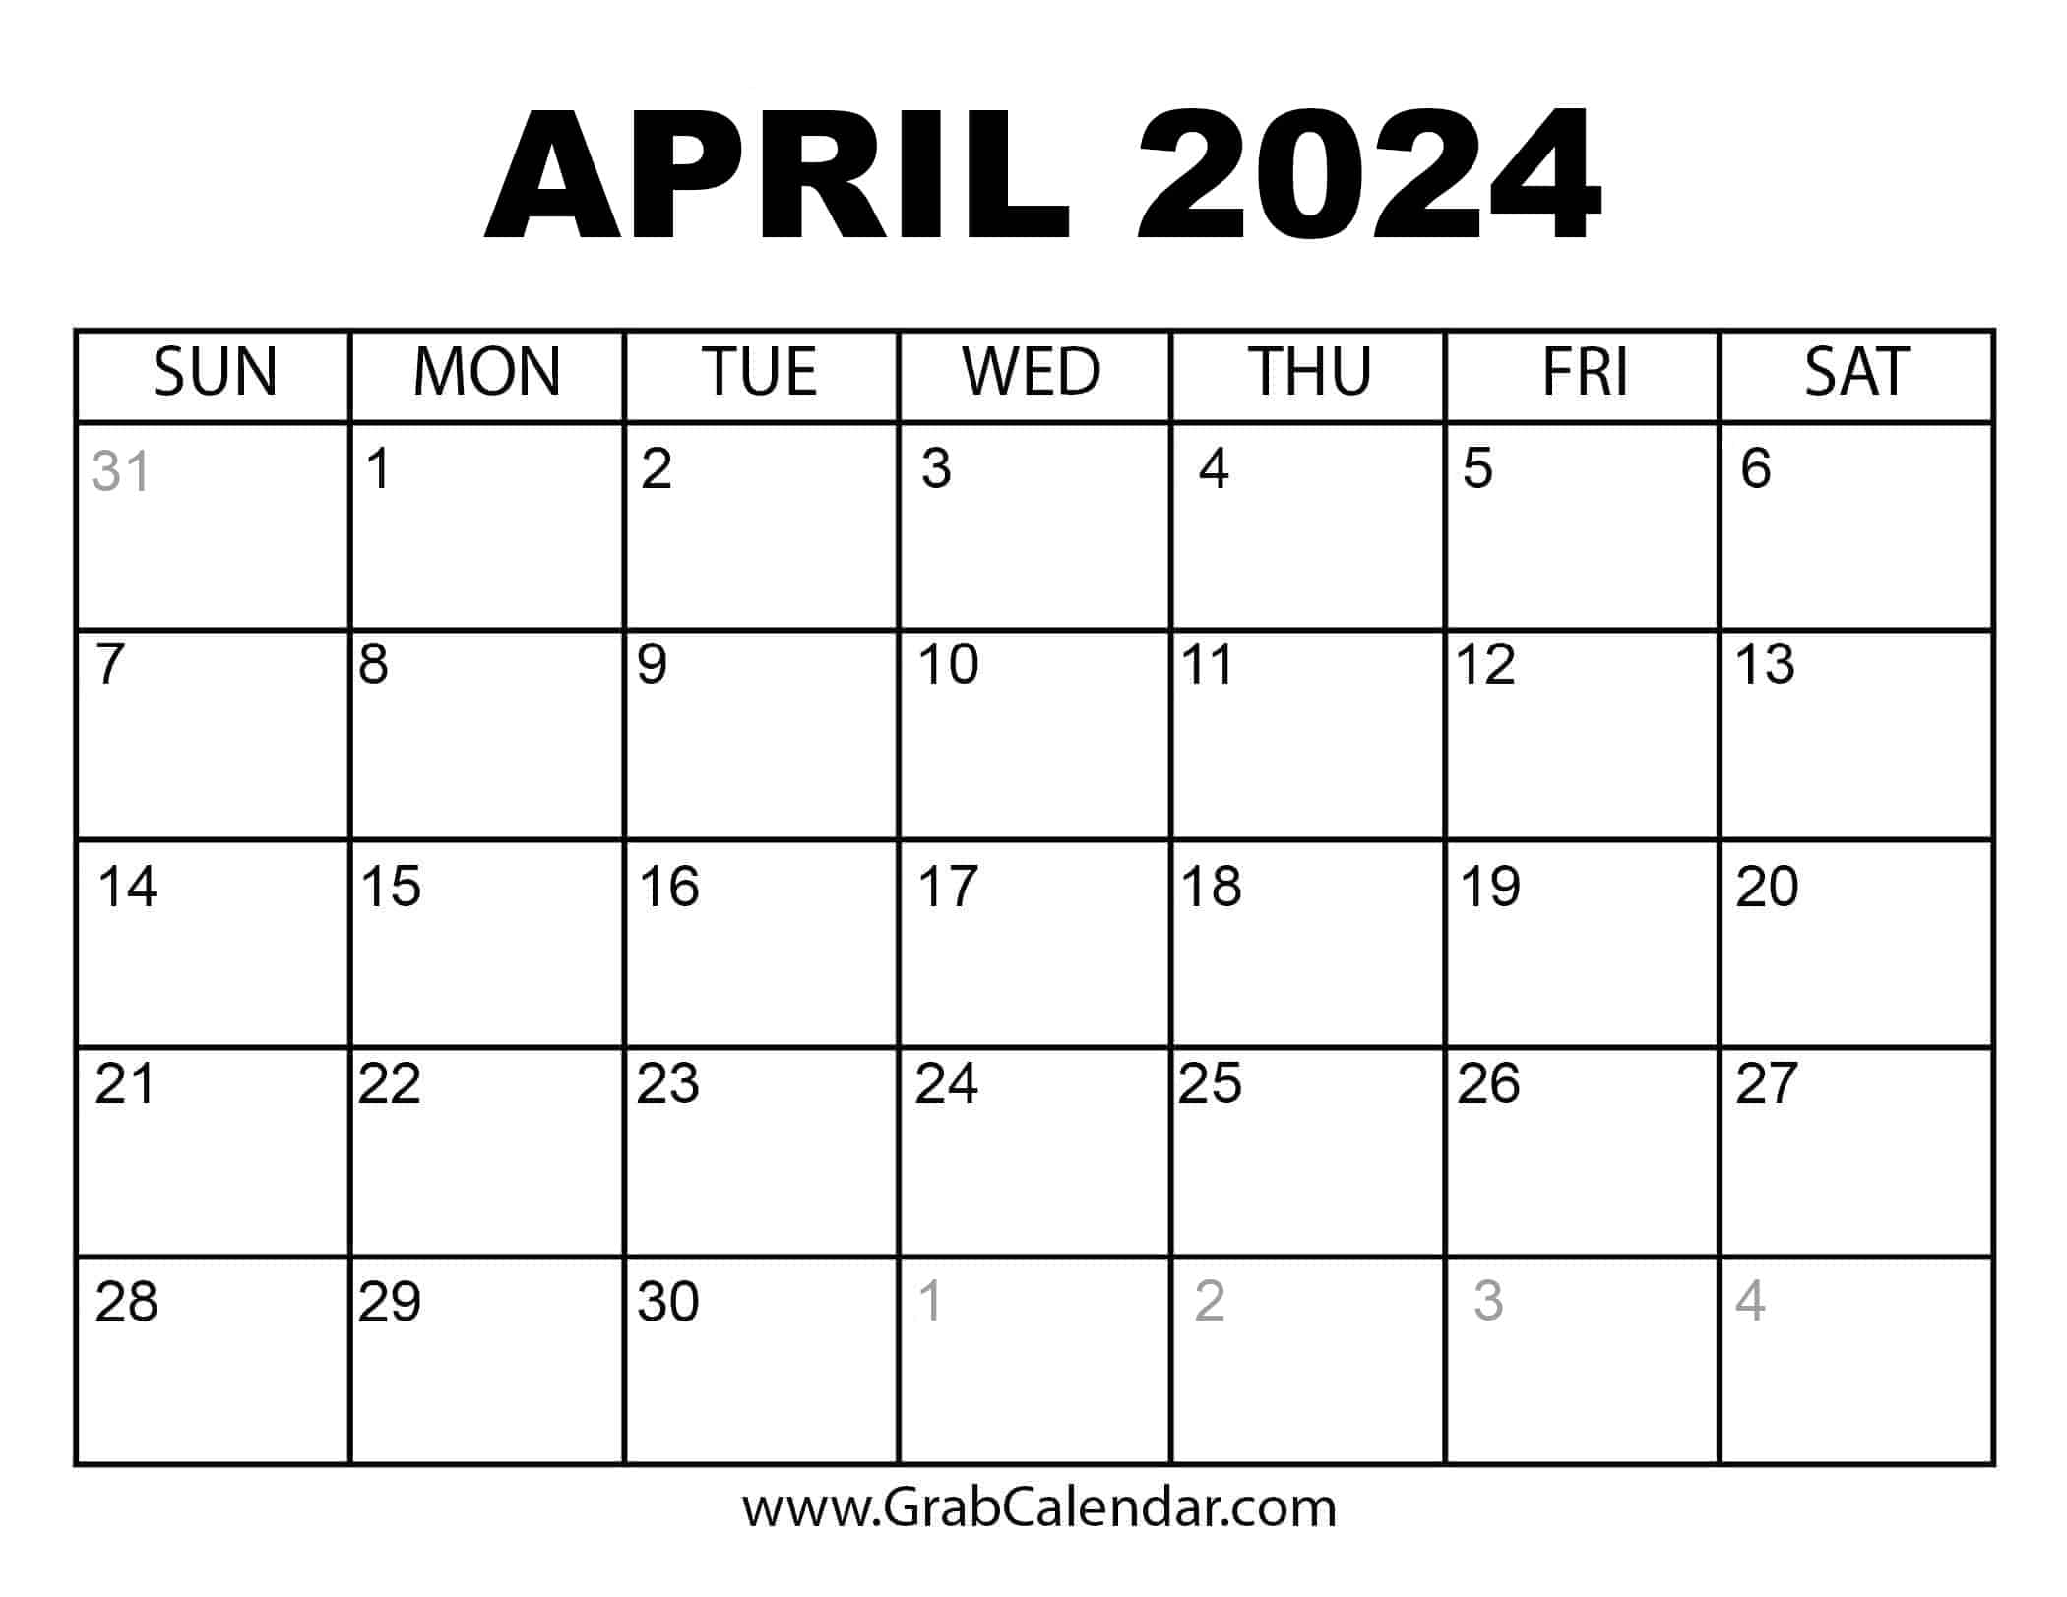

No lessons the week of 3/11- 3/15 for
Spring Break!
Mark your calendar for the Steak Dinner on 4/13
and Big Day of Giving on 5/2!
Volunteers Always Needed!
Thank you for making the magic happen!
If you must cancel your shift, please call 916-685-7433

