NAME:___________________________________________________Phone no.____________________________

**Project R.I.D.E., Inc .** CSUS , Number of hours needed:___

**August 19th to October 18th 2024** Instructor:_____________________

**Please mark all of your availability. We will confirm your schedule with you.**

The first and last shift of every day includes lesson prep and barn chores.

|  |  |  |
| --- | --- | --- |
| Monday | * 7:30am- 10:30am * 10:30am- 1:30pm * 1:30pm- 4:45pm * 4:45pm- 7:30pm | 8/19, 8/26, 9/9, **9/16**, 9/23, 9/30, **10/7**, 10/14  NO LESSONS: 9/2, Labor Day  **Orientations: 9/16, 10/7** |
| Tuesday | * 7:30am- 10:30am * 10:25am-1:30pm * 1:30pm- 4:45pm * 4:45pm- 8:15pm | 8/20, 8/27, 9/3, 9/10, 9/17, 9/24, 10/1, 10/8, 10/15 |
| Wednesday | * 7:30am- 10:30am * 10:25am-1:30pm * 1:30pm- 4:45pm * 4:45pm- 8:15pm | 8/21, 8/28, 9/4, 9/11, 9/18, 9/25, 10/2, 10/9, 10/16 |
| Thursday | * 7:30am- 10:30am * 10:25am-1:30pm * 1:30pm- 4:45pm * 4:45pm- 8:15pm | 8/22, 8/29, 9/5, 9/12, 9/19, 9/26, 10/3, 10/10, 10/17 |
| Friday | * 7:30am- 10:30am * 10:25am-1:30pm * 1:30pm- 3:15pm | 8/23, 8/30, 9/6, **9/13,** 9/20, 9/27, 10/4, 10/11, 10/18  **Orientations: 9/13** |

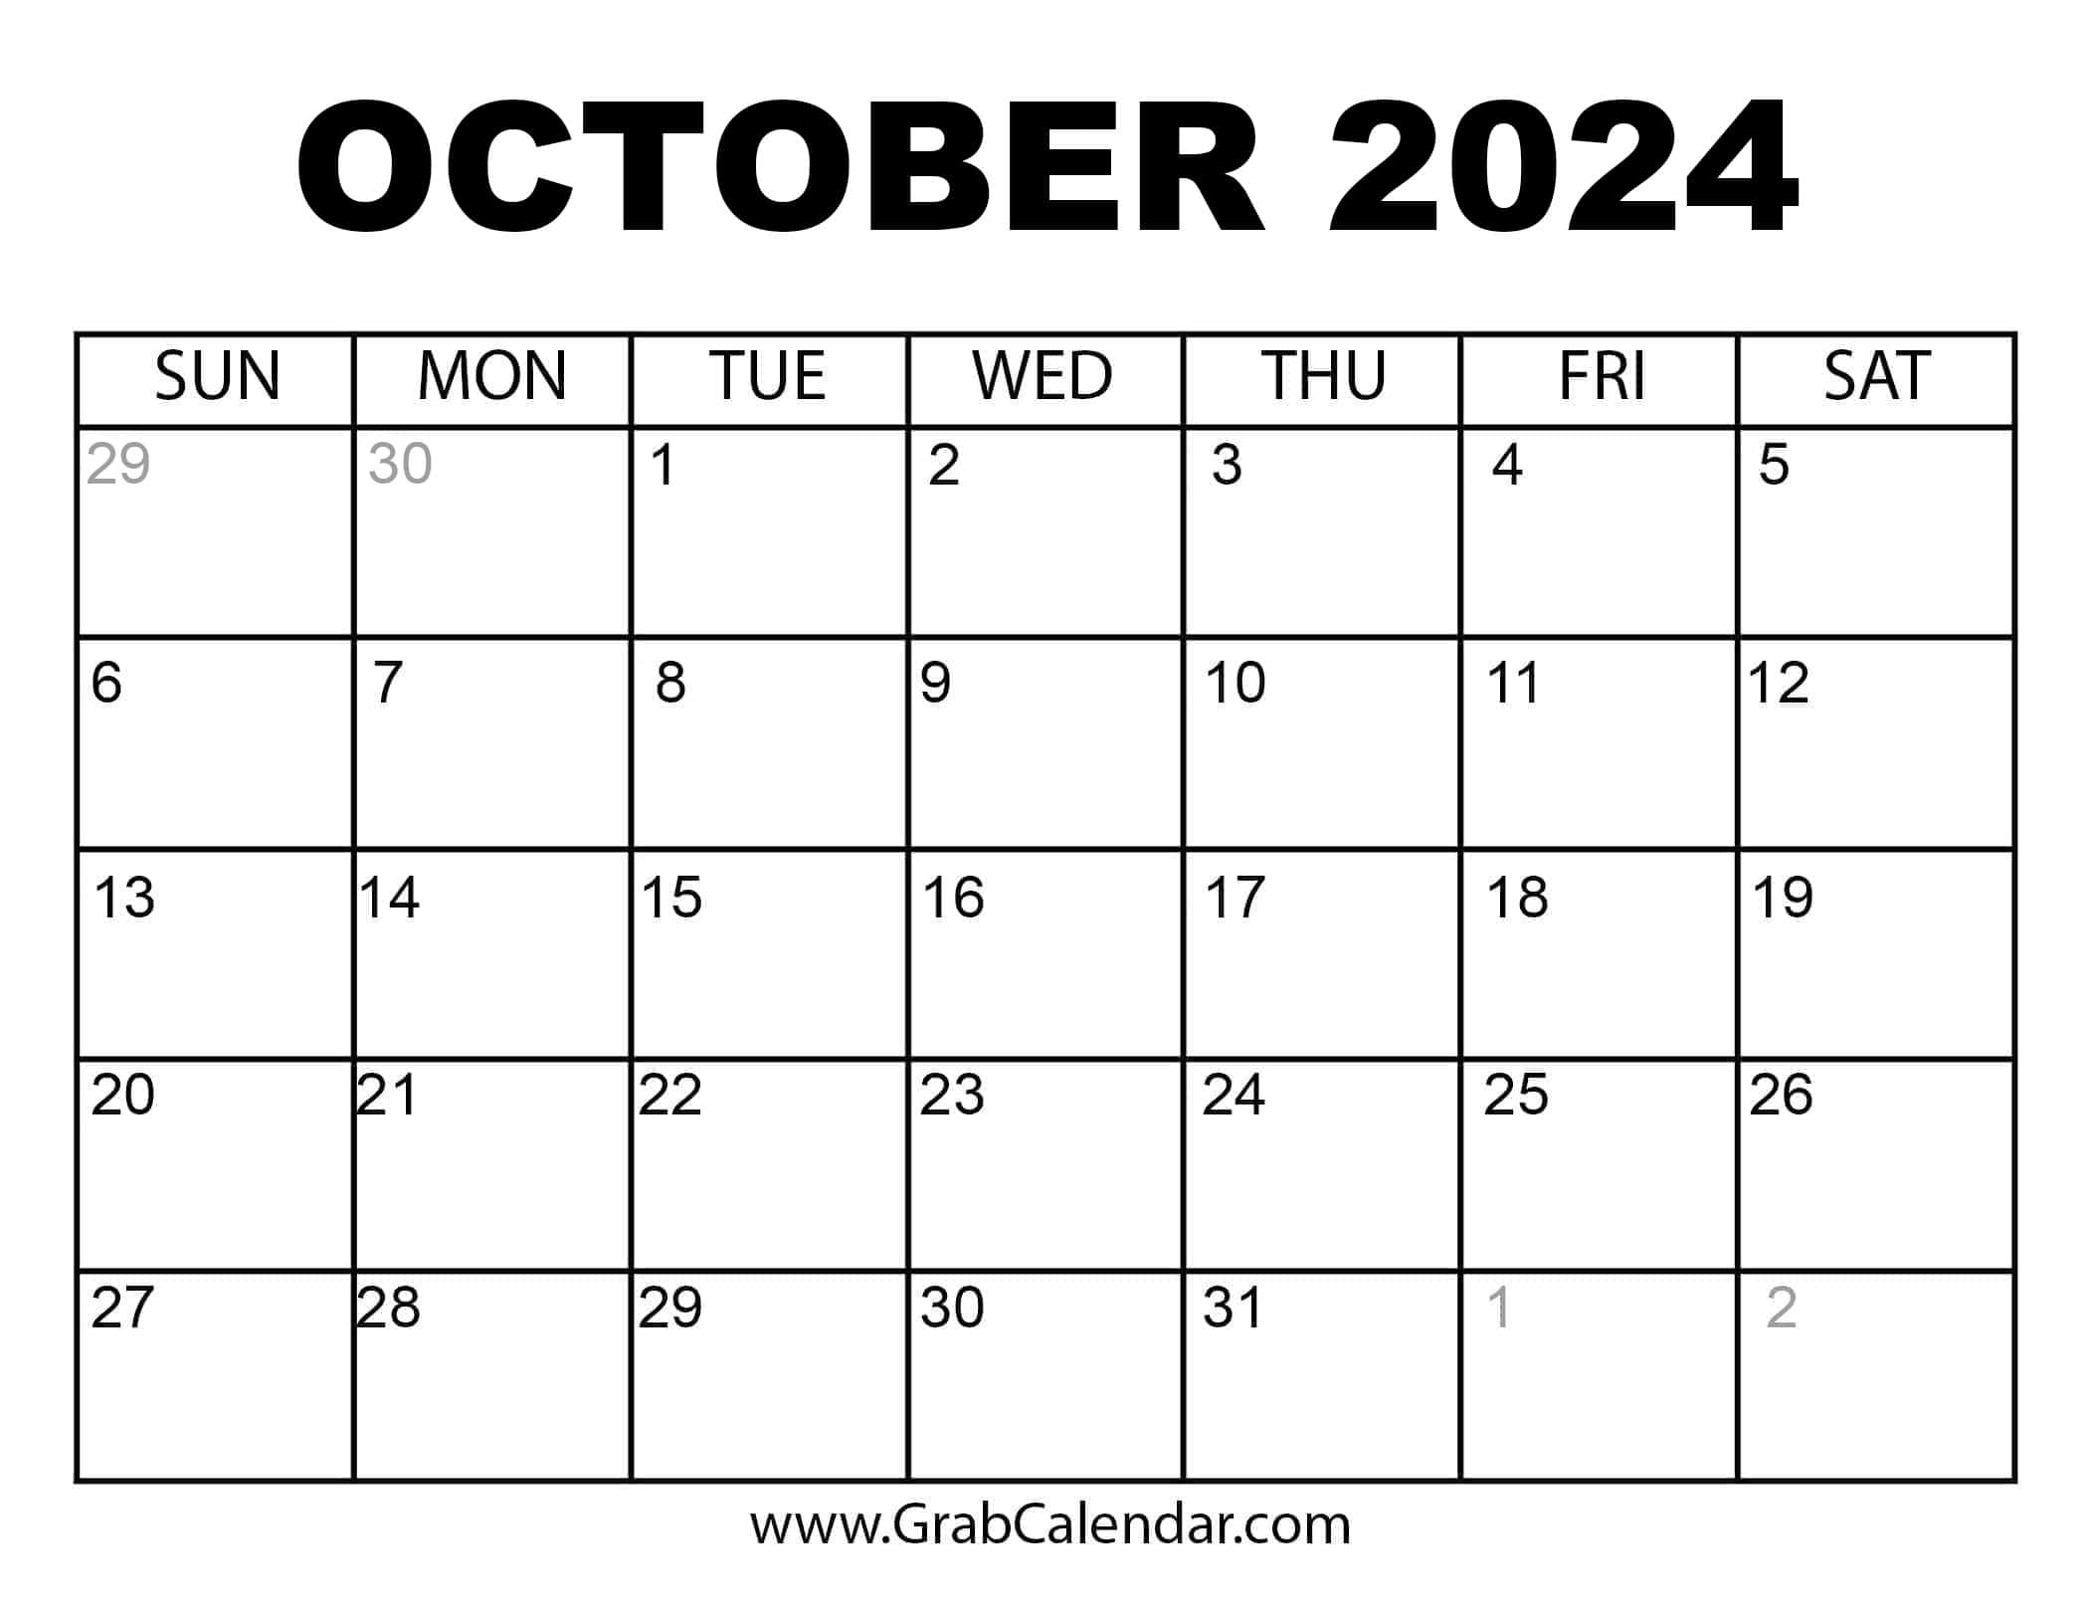

**No Lessons August 12-16**

Mark your calendar for the Spaghetti Feed **10/12**

**Volunteers Needed-See Suzi**

Volunteers Always Needed!

***Thank you for making the magic happen!***

**If you must cancel your shift, please call 916-685-7433**