NAME:___________________________________________________Phone no.____________________________

**Project R.I.D.E., Inc.**

**May 28th to August 9th 2024**

**Please mark all of your availability. We will confirm your schedule with you.**

The first and last shift of every day includes lesson prep and barn chores.

|  |  |  |
| --- | --- | --- |
| Monday | * 7:30am- 10:30am * 10:30am- 1:30pm * 1:30pm- 4:45pm * 4:45pm- 7:30pm | 6/3, 6/10, 6/17, 6/24, 7/1, 7/8, 7/15, 7/22, 7/29, 8/5  NO LESSONS: 5/27, Memorial Day  **Orientations: 6/3,7/8, 8/5** |
| Tuesday | * 7:30am- 10:30am * 10:15am-12:45pm * 12:45pm- 3:15pm * 4:45pm- 8:15pm | 5/28, 6/4, 6/11, 6/18, 6/25, 7/2, 7/9, 7/16, 7/23, 7/30, 8/6  **No Lessons from 2:45pm to 4:45pm** |
| Wednesday | * 7:30am- 10:30am * 10:25am-1:30pm * 1:30pm- 4:45pm * 4:45pm- 8:15pm | 5/29, 6/5, 6/12, 6/19, 6/26, 7/3, 7/10, 7/17, 7/24, 7/31, 8/7 |
| Thursday | * 7:30am- 10:30am * 10:15am-12:45pm * 12:45pm- 3:15pm * 4:45pm- 8:15pm | 5/30, 6/6, 6/13, 6/20, 6/27, 7/11, 7/18, 7/25, 8/1, 8/8  NO LESSONS: 7/4, 4th of July  **No Lessons from 2:45pm to 4:45pm** |
| Friday | * 7:30am- 10:30am * 10:15am-12:45pm * 12:45pm- 3:30pm | 5/31, 6/7, 6/14, 6/21, 6/28, 7/12, 7/19, 7/26, 8/2, 8/9  NO LESSONS: 7/5, |

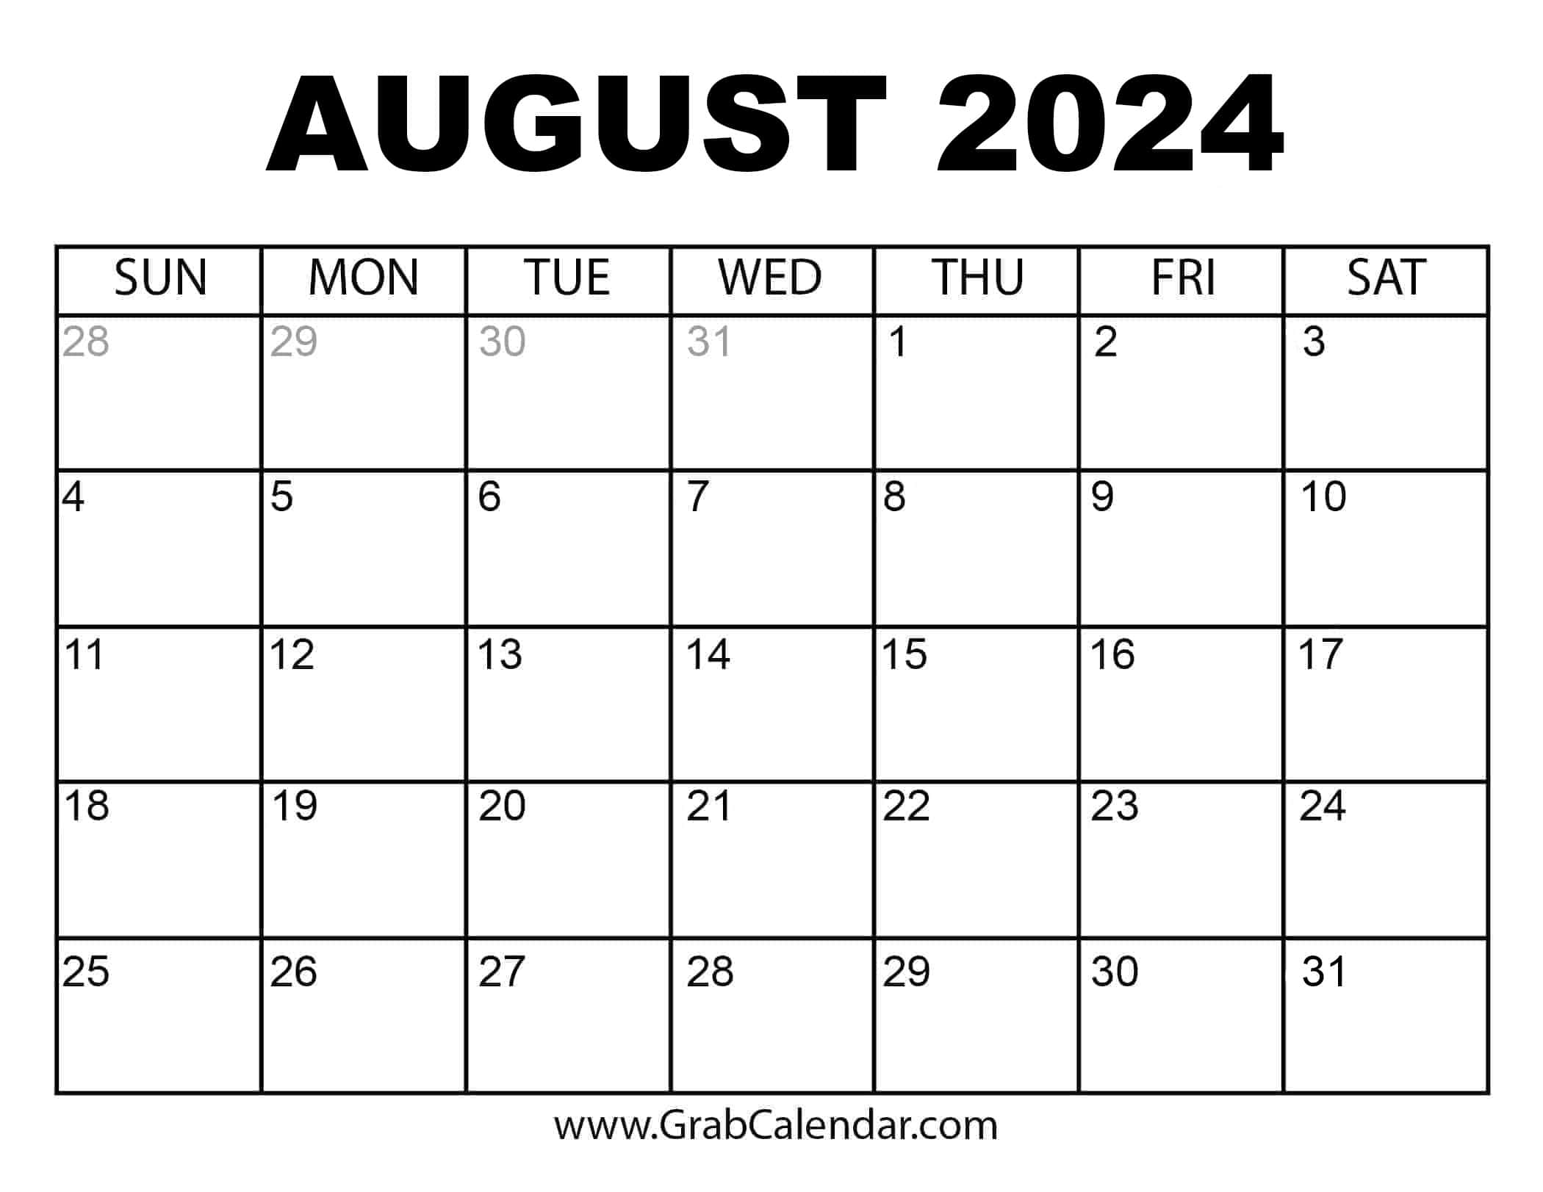

No Lessons July 4th and 5th

Mark your calendar for the Scoop Scoot **6/21**

and Bogle Winery Event **7/12**

Volunteers Always Needed!

***Thank you for making the magic happen!***

**If you must cancel your shift, please call 916-685-7433**