NAME:___________________________________________________Phone no.____________________________

**Project R.I.D.E., Inc .** CSUS , Number of hours needed:___

**October 21st to December 20th 2024** Instructor:_____________________

**Please mark all of your availability. We will confirm your schedule with you.**

The first and last shift of every day includes lesson prep and barn chores.

|  |  |  |
| --- | --- | --- |
| Monday | * 7:30am- 10:30am * 10:30am- 1:30pm * 1:30pm- 4:45pm * 4:45pm- 7:30pm | 10/21, 10/28, **11/4,** 11/18, 12/2, 12/9, 12/16  No lessons 11/11 Veteran’s Day  NO LESSONS: 11/25 Thanksgiving week  **Orientations: 11/4** |
| Tuesday | * 7:30am- 10:30am * 10:25am-1:30pm * 1:30pm- 4:45pm * 4:45pm- 8:15pm | 10/22, 10/29, 11/5, 11/12, 11/19, 12/3, 12/10, 12/17  NO LESSONS: 11/26 Thanksgiving week |
| Wednesday | * 7:30am- 10:30am * 10:25am-1:30pm * 1:30pm- 4:45pm * 4:45pm- 8:15pm | 10/23, 10/30, 11/6, 11/13, 11/20, 12/4, 12/11, 12/18  NO LESSONS: 11/27 Thanksgiving week |
| Thursday | * 7:30am- 10:30am * 10:25am-1:30pm * 1:30pm- 4:45pm * 4:45pm- 8:15pm | 10/24, **10/31,** 11/7, 11/14, 11/21, 12/5, 12/12, 12/19  *Barn closes at 5pm on Halloween*  NO LESSONS: 11/28 Thanksgiving week |
| Friday | * 7:30am- 10:30am * 10:25am-1:30pm * 1:30pm- 3:15pm | 10/25, 11/1, 11/8, 11/15, 11/22, 12/6, 12/13, 12/20  NO LESSONS: 11/29 Thanksgiving week |

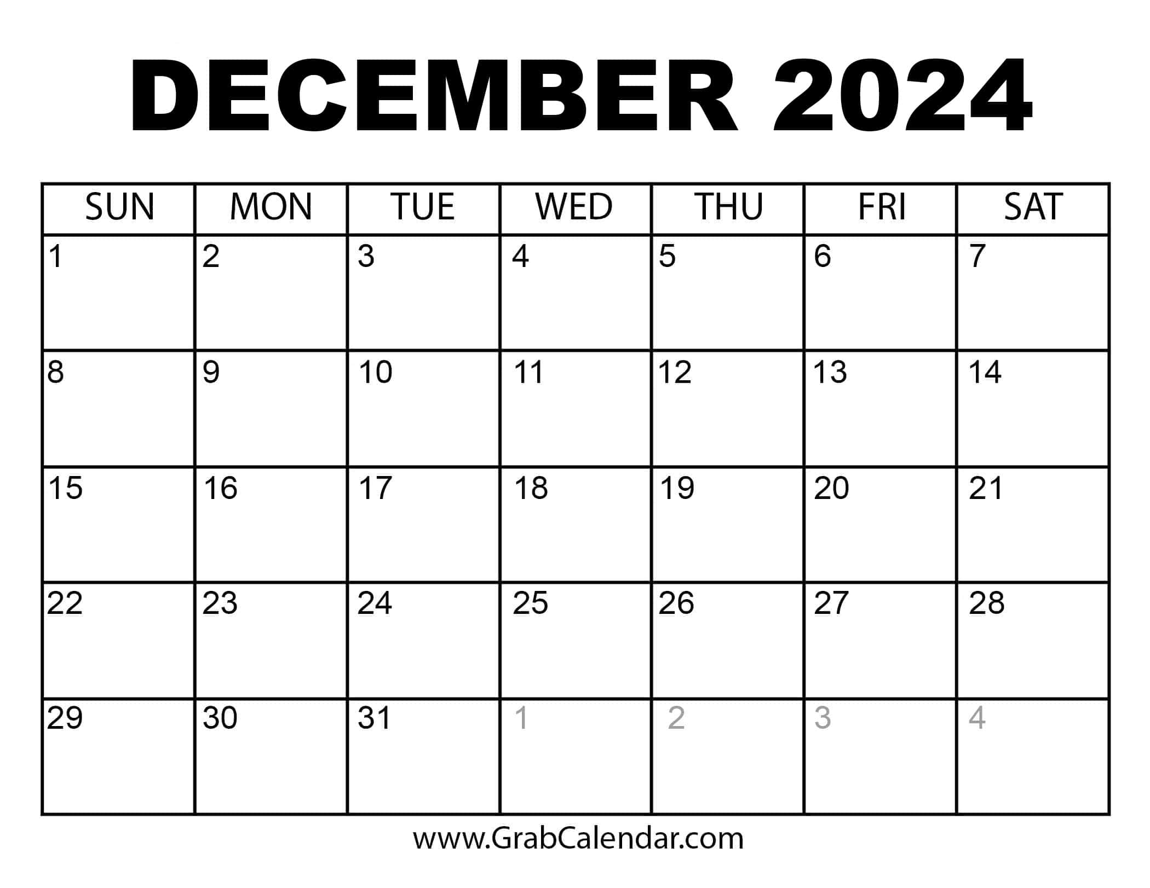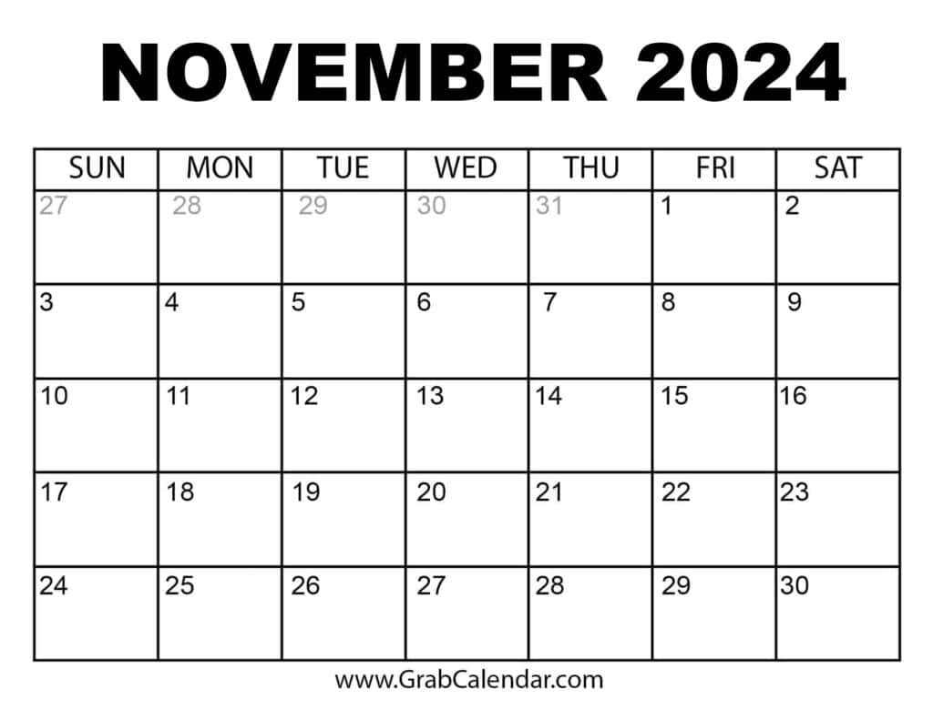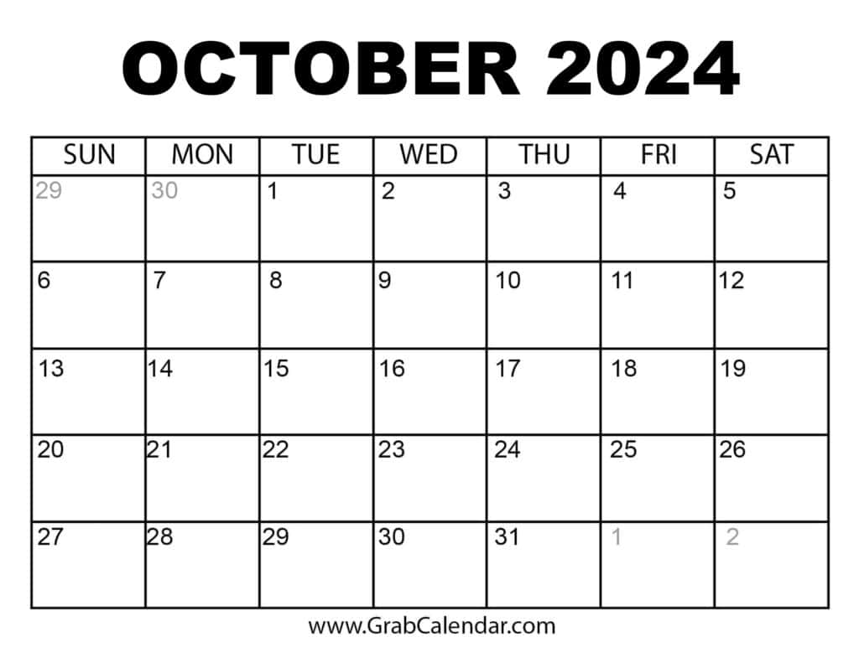

**No Lessons Thanksgiving week 11/25-11/29**

Volunteers Always Needed!

***Thank you for making the magic happen!***

**If you must cancel your shift, please call 916-685-7433**