NAME:___________________________________________________Phone no.____________________________

**Project R.I.D.E., Inc .** CSUS , Number of hours needed:___

**January 6th to March 14th 2024** Instructor:_____________________

**Please mark all of your availability. We will confirm your schedule with you.**

The first and last shift of every day includes lesson prep and barn chores.

|  |  |  |
| --- | --- | --- |
| Monday | * 7:30am- 10:30am * 10:30am- 1:30pm * 1:30pm- 4:45pm * 4:45pm- 7:30pm | 1/6, 1/13, 1/20, 1/27, 2/3, 2/10, 2/24, 3/3, 3/10  No lessons : 2/17-Holiday  **Orientations: 1/6, 2/10, 3/3** |
| Tuesday | * 7:30am- 10:30am * 10:25am-1:30pm * 1:30pm- 4:45pm * 4:45pm- 8:15pm | 1/7, 1/14, 1/21, 1/28, 2/4, 2/11, 2/18, 2/25, 3/4, 3/11 |
| Wednesday | * 7:30am- 10:30am * 10:25am-1:30pm * 1:30pm- 4:45pm * 4:45pm- 8:15pm | 1/ 8, 1/15, 1/22, 1/29, 2/5, 2/12, 2/19, 2/26, 3/5, 3/12 |
| Thursday | * 7:30am- 10:30am * 10:25am-1:30pm * 1:30pm- 4:45pm * 4:45pm- 8:15pm | 1/9, 1/16, 1/23, 1/30, 2/6, 2/13, 2/20, 2/27, 3/6, 3/13 |
| Friday | * 7:30am- 10:30am * 10:25am-1:30pm * 1:30pm- 3:15pm | 1/10, 1/17, 1/31, 2/7, 2/14, 2/21, 2/28, 3/7, 3/14  NO LESSONS: 1/24 Crab Feed Prep  **Orientation: 2/7** |

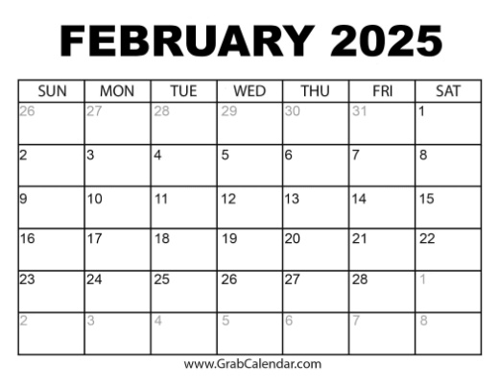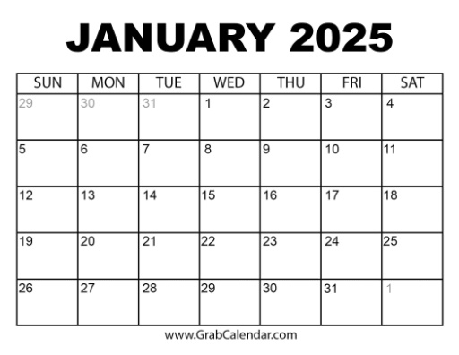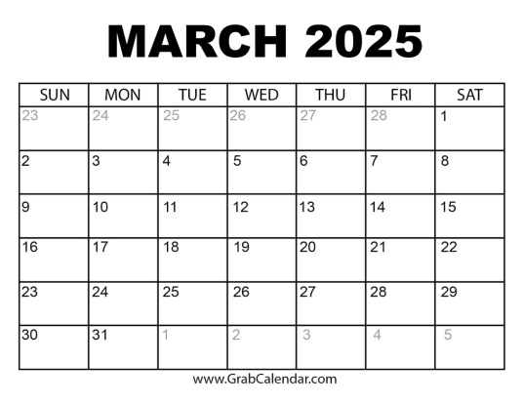

Crab Feed Sat. January 25, 2025

No lessons Friday, 1/24

**Spring Break- 3/17-3/22 No Lessons**

Volunteers Always Needed!

***Thank you for making the magic happen!***

**If you must cancel your shift, please call 916-685-7433**