NAME:___________________________________________________Phone no.____________________________

**Project R.I.D.E., Inc .** CSUS , Number of hours needed:___

**June 2nd to August 8th 2025** Instructor:_____________________

**Please mark all of your availability. We will confirm your schedule with you.**

The first and last shift of every day includes lesson prep and barn chores.

|  |  |  |
| --- | --- | --- |
| Monday | * 7:30am- 10:30am * 10:30am- 1:30pm * 1:30pm- 4:45pm * 4:45pm- 7:30pm | 6/2, 6/9, 6/16, 6/23, 6/30, 7/7, 7/14, 7/21, 7/28, 8/4  **Orientations: 6/2, 7/7, 8/4** |
| Tuesday | * 7:30am- 10:30am * 10:25am-1:30pm * 1:30pm- 4:45pm * 4:45pm- 8:15pm | 6/3, 6/10, 6/17, 6/24, 7/1, 7/8, 7/15, 7/22, 7/29, 8/5 |
| Wednesday | * 7:30am- 10:30am * 10:25am-1:30pm * 1:30pm- 4:45pm * 4:45pm- 8:15pm | 6/4, 6/11, 6/18, 6/25, 7/2, 7/9, 7/16, 7/23, 7/30, 8/6 |
| Thursday | * 7:30am- 10:30am * 10:25am-1:30pm * 1:30pm-4:45pm | 6/5, 6/12, 6/26, 7/3, 7/10, 7/17, 7/24, 7/31, 8/7  No Lessons 6/19 |
| Friday | * 7:30am- 10:30am * 10:25am-1:30pm * 1:30pm- 3:15pm | 6/6, 6/13, 6/27, 7/11, 7/18, 7/25, 8/1, 8/8  No lessons 6/20, 7/4 |

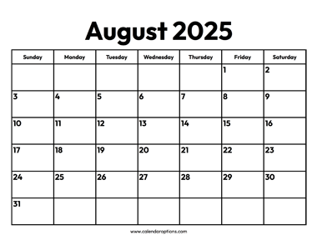

**June 6th Golf Tournament**

**June 6th Scoop Scoot**

Volunteers Always Needed!

***Thank you for making the magic happen!***

**If you must cancel your shift, please call 916-685-7433**