NAME: __________________________________________________ Phone no.:____________________________
Project R.I.D.E., Inc . CSUS, Number of hours needed: ____
June 1st to August 7th 2026 Instructor:_____________________
Please mark all of your availability. We will confirm your schedule with you.
The first and last shift of every day includes lesson prep and barn chores.

Monday | - 7:30am- 10:30am  - 10:30am- 1:30pm  - 1:30pm- 4:45pm  - 4:45pm- 7:30pm | 6/1, 6/8, 6/15, 6/22, 6/29, 7/6, 7/13, 7/20, 7/27, 8/3  Orientations: 7/6, 8/3
Tuesday | - 7:30am- 10:30am  - 10:25am-1:30pm  - 1:30pm- 4:45pm  - 4:45pm- 8:15pm | 6/2, 6/9, 6/16, 6/23, 6/30, 7/7, 7/14, 7/21, 7/28, 8/4
Wednesday | - 7:30am- 10:30am  - 10:25am-1:30pm  - 1:30pm- 4:45pm  - 4:45pm- 8:15pm | 6/3, 6/10, 6/17, 6/24, 7/1, 7/8, 7/15, 7/22, 7/29, 8/5
Thursday | - 7:30am- 10:30am  - 10:25am-1:30pm  - 1:30pm- 4:45pm | 6/4, 6/11, 6/18, 6/25, 7/2, 7/9, 7/16, 7/23, 7/30, 8/6
Friday | - 7:30am- 10:30am  - 10:25am-1:30pm  - 1:30pm- 3:15pm | 6/12, 6/26, 7/10, 7/17, 7/24, 7/31, 8/7  Closed: 6/5 (No lessons),  6/19 (Holiday), 7/3 (No lessons)

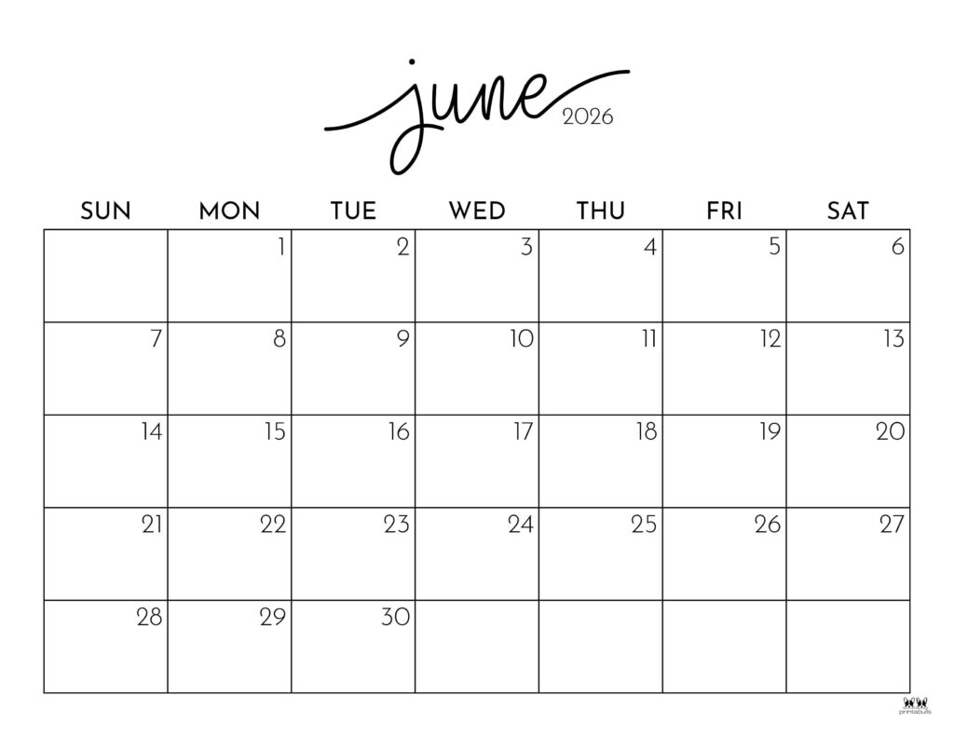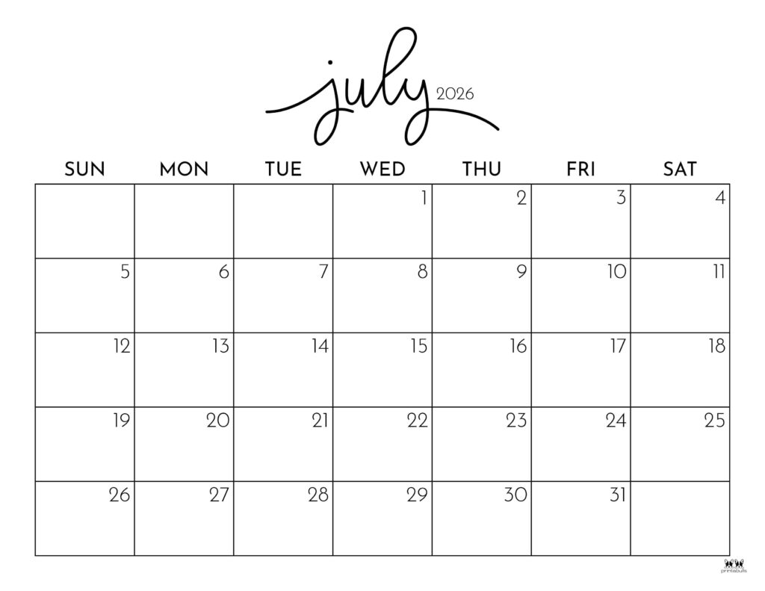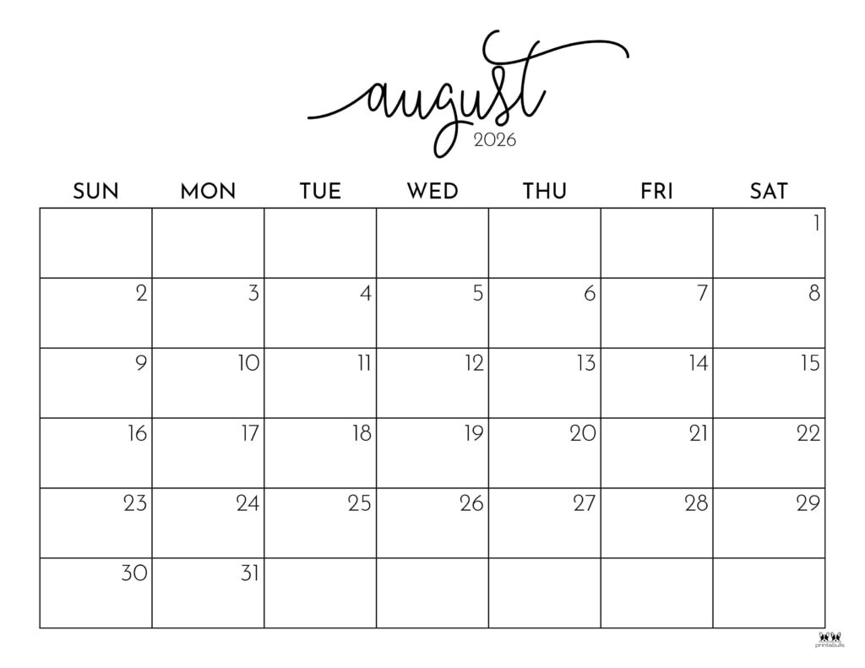
Summer Break: 8/10-8/14 No Lessons
Golf Tournament Fri. June 5, 2026
No lessons & closed Friday, 6/19-Holiday
No Lessons & closed Friday, 7/3- Holiday

Volunteers Always Needed!
Thank you for making the magic happen!
If you must cancel your shift, please call 916-685-7433

